**Thermoregulation in Ectotherms**

Ectotherms do not rely on metabolism for producing body heat. Instead they modify their behaviour and have structural features which enable them to increase or decrease their body temperature.

**Background Research:**

You need research examples of ectotherms in warmer environments and cooler environments. Do you recognise any patterns in structural characteristics or behavioural responses of ectotherms in each of these environments?

**Your task:**

Design an experiment that models temperature changes in an ectotherm. Your investigation should explore the relationship between surface area to volume ratio and heat exchange.



**Available equipment:**

* Heater/ heat lamps
* Ice
* Plasticine
* Data loggers with temperature probes

**Data collection:**

You need to decide how much data to collect and if there are any ethical consideration that need to be made in this investigation. You will also need to conduct a risk assessment plan (refer to Chapter 14 of your textbook) and include this in your written report.

**Written Report:**

You will need to write a scientific report on your investigation. Use the guidelines provided by your teacher to determine what to include in your report and how to structure it correctly. Your written report will not be formally marked but can be used during the in-class validation test.

**Validation Test:**

You will sit an in-class validation test on ____________________________. You may bring in your written report to use during the validation test.



**Year 12 Biology**

**Thermoregulation Validation Test**

|  |
| --- |
| Name: |
| Teacher: |

|  |  |  |  |
| --- | --- | --- | --- |
|  | Marks Received | Marks Available | Percentage |
| Total |  | 40 |  |

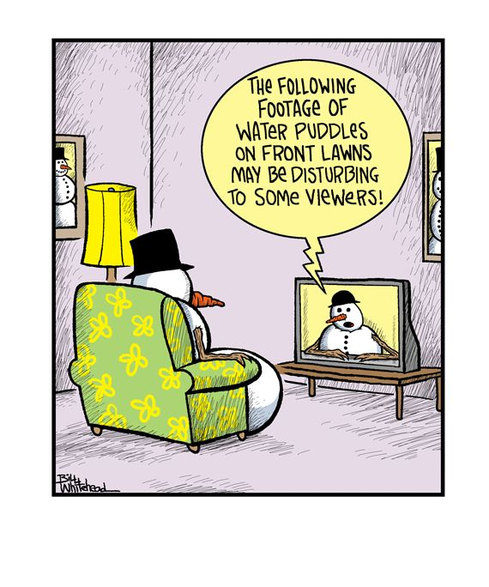

Weighting: 5%

Time: 40 minutes

1. What was your hypothesis?

|  |
| --- |
|  |

(1 mark)

2. Identify the independent and dependant variables in this investigation

|  |
| --- |
|  |

(2 marks)

3. Identify **three** extraneous (uncontrolled) variables in either the **method or** **equipment** used in the investigation. Describe how you could control each variable.

|  |
| --- |
|  |
|  |
|  |
|  |
|  |
|  |
|  |
|  |
|  |
|  |
|  |
|  |
|  |
|  |
|  |

(3 marks)

4. Describe one risk in this investigation and explain the precautions taken to minimize this risk during data collection.

|  |
| --- |
|  |
|  |

(2 marks)

5. Biologist would often need to analyse their data before identifying patterns and trends. Below is a collection of second data regarding temperature change in an ectotherm over a 25 minute period of time. Calculate the mean, median and range of the core body temperatures provided. You must show full working to receive full marks.

|  |  |
| --- | --- |
| **Time (minutes)** | **Core Body Temperature (°C)** |
| 0 | 20 |
| 5 | 23 |
| 10 | 25 |
| 15 | 27 |
| 20 | 29 |
| 25 | 32 |

(4 marks)

6. Describe an advantage of using the median rather than the mean in the analysis data.

|  |
| --- |
|  |
|  |

(2 marks)

7. Construct a graph of your average results collected in your investigation.



(5 marks)

8. Use evidence from your data to describe patterns or trends in your results.

|  |
| --- |
|  |
|  |
|  |

(2 marks)

9. What conclusions can be made based on your results? Refer to methods of heat transfer in your explanation.

|  |
| --- |
|  |
|  |
|  |

(2 marks)

10. Discuss two advantages of using plasticine in the investigation instead of living ectotherms.

|  |
| --- |
|  |
|  |
|  |

(2 marks)

11. Discuss two limitations of using plasticine instead of living ectotherms.

|  |
| --- |
|  |
|  |
|  |

(2 marks)

12. How would you expect your results to vary if this investigation were repeated using living ectotherms? Explain your answer.

|  |
| --- |
|  |
|  |
|  |

(2 marks)

13. Were your results reliable? Explain your answer.

|  |
| --- |
|  |
|  |
|  |

(2 marks)

14. Were your results valid? Explain your answer.

|  |
| --- |
|  |
|  |
|  |

(2 marks)

Consider the following second hand data about Potoroos.

15. One area of the Adelie Penguin’s body surface that is not well insulated is its feet. This could be a problem for a bird that spends a lot of time standing on ice or immersed in icy water.

An investigation was carried out to try and determine the mechanisms that enable the penguin to tolerate such cold conditions around its feet. Under laboratory conditions in an Antarctic research station, a penguin was connected to two continuous temperature sensors. One measured the temperature in a foot and the other measured core body temperature. The penguin was made to stand in icy sea water at -1.5°C. After 90 minutes, the foot was injected with a substance that causes the muscles in the wall of the blood vessels to relax. The results of this investigation are shown below.

Core Body Temperature (°C)

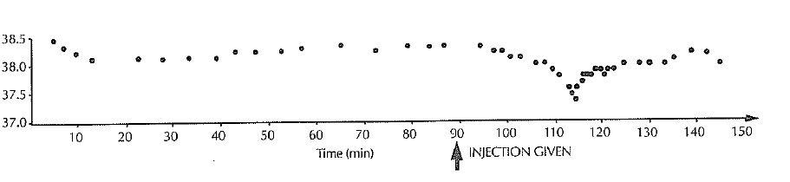

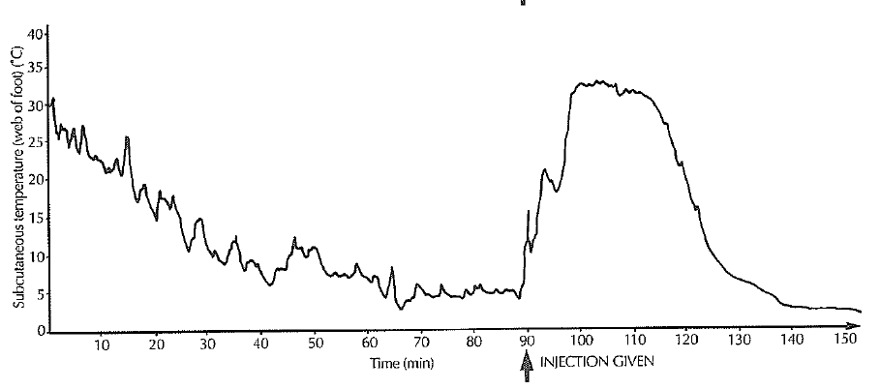

1. From the information provided in the graph above, explain how the Adelie penguin normally reduces heat loss from its feet.

|  |
| --- |
|  |
|  |
|  |
|  |

(3 marks)

1. The rate of heat loss changed after the injection of the muscle relaxant. Describe the sequence of events caused by the injection. Discuss both the changes in the foot and in the body.

|  |
| --- |
|  |
|  |
|  |
|  |
|  |
|  |

(4 marks)